**Determination of Fp,inst**

The value of Fp,inst,mean from the template is 3144.2 kN, which is ≈ 80% of the yield strength. In the new IEC document there is only a guideline for torque tightened HV bolts in Annex C. Is another annex for tension tightened bolts planned?

**Loss of preload due to plastic strain**

I get different results for Z_loss but comparable results for FS_loss

For D=7500mm; s=72mm; c=194.5mm; ∆Zdw=-123.3 kN



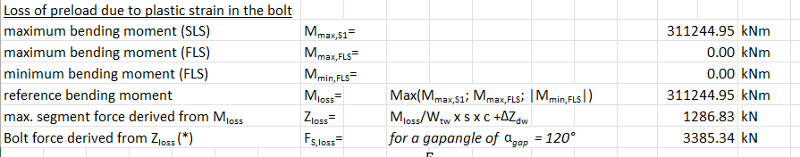

Ein Bild, das Text, Screenshot, Schrift, Zahl enthält.

Is the equation for Z_loss correct?

**Preload loss due to settlement**

I calculate the preload loss as:

Ein Bild, das Text, Screenshot, Reihe, Schrift enthält.

In the validation sheet, the preload loss is calculated without the consideration of the limit value of 50 mü:

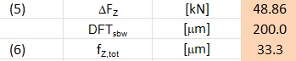

**Stiffness values**

As described in the IEC I calculated the stiffness values for both flanges and averaged the results



Here is an example of the calculation



Ein Bild, das Schrift, Text, Handschrift, Reihe enthält.

E=210000 MPa

G=80769 MPa

30° Gap, top flange

* s=72mm
* Icf= 290000000 mm^4
* Acf=87000 mm^2
* Lgap,shell=pi*(7500-72)/12=1944.65
* Lgap,fl=(Do+Di)/2*30/360=pi*(7500+6630)/2*30/360=1849.61
* k_fac=1.8
* Kshell,ini=210000*72/(1.8*1944.65)= 4319.55
* Kfl= 1781.51N/mm/mm

30° Gap, bot flange

* S=86mm
* Icf= 290000000 mm^4
* Acf=87000 mm^2
* K_fac = 1.8
* Lgap,shell = pi*(7500-86)/12 = 1940.98
* Lgap,fl=(Do+Di)/2*30/360=pi*(7500+6630)/2*30/360=1849.61
* Kshell,ini = 210000*86/(1.8*1940.98) = 5169.21
* Kfl= 1781.51N/mm/mm

When i compare my results to the ones from the template I see differences up to 21%, especially for kfl:

Ein Bild, das Text, Screenshot, Schrift, Zahl enthält.

I can’t figure out whats wrong, the equations I used are “correct” as described in IEC. Is the main calculation process for this step correct?

**Polynomial coefficients**

This is from the 30°Gap

Ein Bild, das Text, Schrift, Reihe, Zahl enthält.

From template: alpha_k= 2.268 and Z0= 2068.3; delta_Zgap= 1180.0; delta_Z_dw=-123.3

For Z2 i get:

Ein Bild, das Schrift, Text, Reihe, Handschrift enthält.
= 2014.717

For Z3 i get:

Ein Bild, das Text, Schrift, Reihe, Screenshot enthält.
=234.5588.

For Z4 i get:

Ein Bild, das Schrift, Text, weiß, Typografie enthält.
= -1303.3

All those values differ from the reference points shown above.